# Databases Exam (June 2015) – Diablo

Your exam consists of several parts, explained below. You may work independently on each exam part. Submit your solutions in the automated judge system: <https://judge.softuni.bg/Contests/101/Databases-Exam-12-July-2015>.

## Part I – Preliminary Setup

The automated judge system will expect from you to submit **only the output of your queries, and not your actual queries**. The output should be **comma delimited (without spaces** in the delimiter), including column **headers not surrounded by quotes** and including the **rows affected** by the query.

A sample output could be:

|  |
| --- |
| Username,First Name,Registered On,Email  Joiner,Adriano,2014-07-06,Joiner@gmail.com  JonSkeet,Jon,2013-02-03,JonSkeet@yahoo.com  HonzaBrabec,Honza,2012-12-08,HonzaBrabec@brabec.com  RaviKumar,Ravi,2012-08-22,kumar@abv.bg  (4 row(s) affected) |

To achieve this:

1. Open **SQL Server Management Studio**
2. Click on **Tools *-> Options***

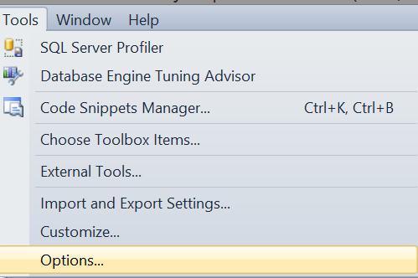

1. Click on **Query Results -> SQL Server -> Results to Text**
2. Change the **dropdown** in the upper right corner to “**Comma delimited**”
3. Ensure the **checkbox** **“Include column headers in the result set”** is **checked**

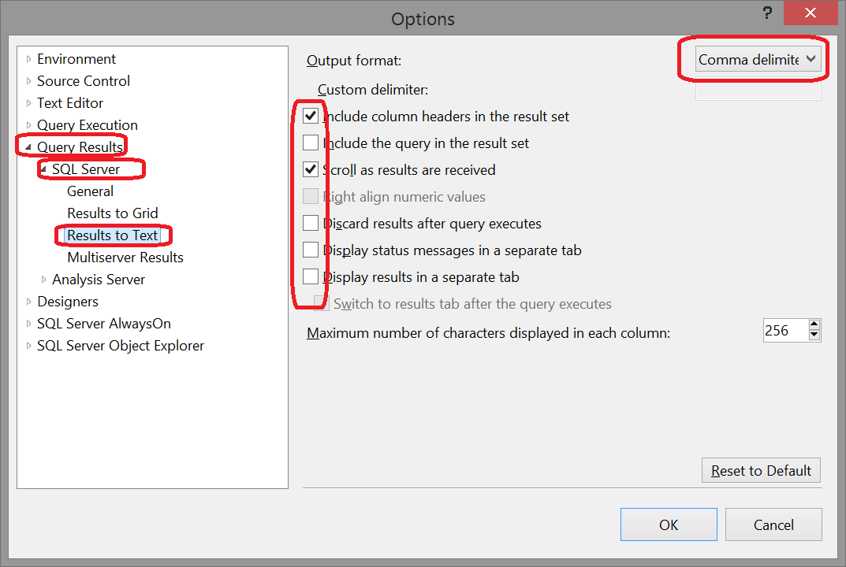

1. Change the **text box “Maximum number of characters displayed in each column”** to **8192**

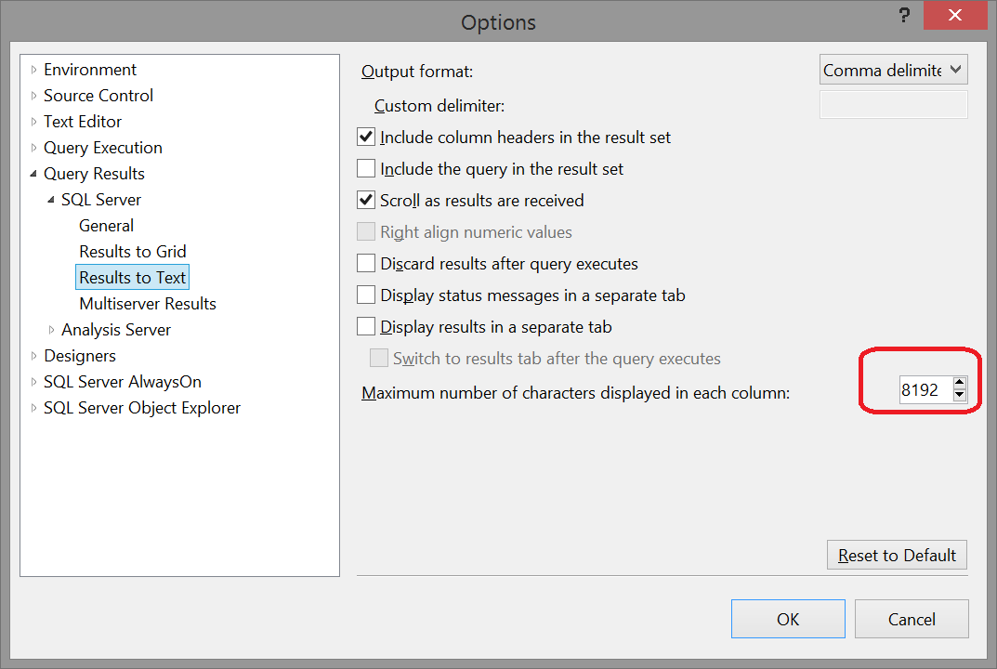

1. Click **OK**
2. Restart **SQL Server Management Studio**
3. The standard output is still Grid. You can use it for easier check if the output is like in the grid in this document, but **in order to submit comma delimited text you need to switch to Results to Text. Press CTRL + T** or click the icon from the screenshot below **before executing your query**



1. You can **optionally** switch the default execution to be **Results to text, if you don’t want to click CTRL + T each time** before executing a query for evaluation

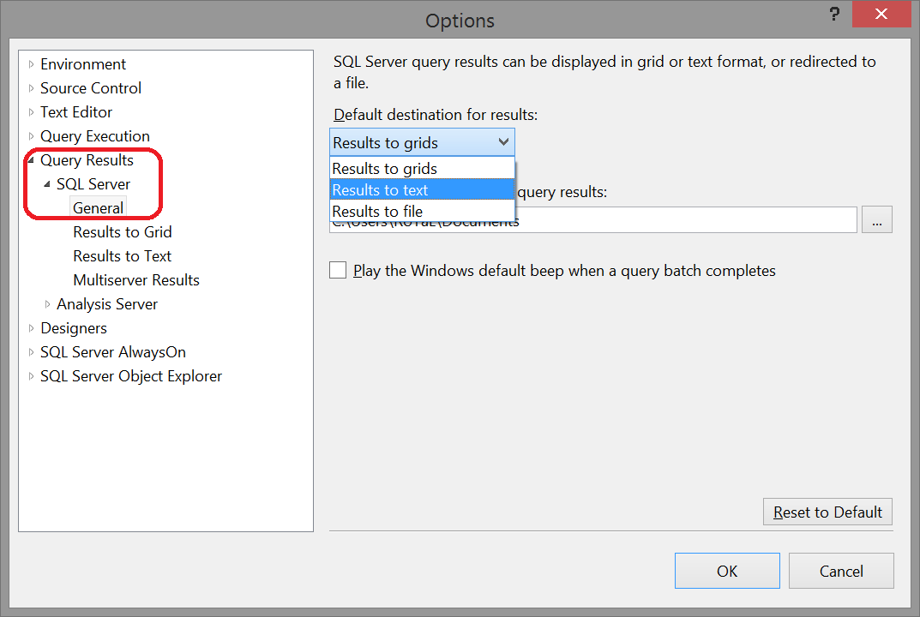

* 1. Repeat steps **7. and 8.**

## Part II – SQL Queries

You are given an **MS SQL Server database "Diablo"** holding users, games, items, characters and statistics available as SQL script. Your task is to write SQL queries for displaying data from the given database. In all problems, please **name the columns exactly like in the sample tables below**.

### All Diablo Characters

Display all **characters** in alphabetical order. Submit for evaluation the result text comma separated with headers.

|  |
| --- |
| **Name** |
| Amazon |
| Assassin |
| Barbarian |
| … |

1 score

### Games from 2011 and 2012 year

Find the top 50 games ordered by start date, then by name of the game. Display only games from 2011 and 2012 year. Display start date in the format “**YYYY-MM-DD**”. Submit for evaluation the result text comma separated with headers.

|  |  |
| --- | --- |
| **Game** | **Start** |
| Rose Royalty | 2011-01-05 |
| London | 2011-01-13 |
| Broadway | 2011-01-16 |
| … | … |

2 score

### User Email Providers

Find all users along with information about their email providers. Display the username and email provider. Sort the results by email provider alphabetically, then by username. Submit for evaluation the result text comma separated with headers.

|  |  |
| --- | --- |
| **Username** | **Email Provider** |
| Pesho | abv.bg |
| monoxidecos | astonrasuna.com |
| bashsassafras | balibless.com |
| … | … |

2 score

### Get users with IPAddress like pattern

Find all users along with their IP addresses sorted by username alphabetically. Display only rows that IP address matches the pattern: “**\*\*\*.1^.^.\*\*\***”.

Legend: **\*** - one symbol, **^** - one or more symbols

|  |  |
| --- | --- |
| **Username** | **IP Address** |
| bindbawdy | 192.157.20.222 |
| evolvingimportant | 223.175.227.173 |
| inguinalself | 255.111.250.207 |
| … | … |

2 score

### Show All Games with Duration and Part of the Day

Find all games with part of the day and duration sorted by game name alphabetically then by duration and part of the day. **Parts of the day** should be **Morning** (time is >= 0 and < 12), **Afternoon** (time is >= 12 and < 18), **Evening** (time is >= 18 and < 24). **Duration** should be **Extra** **Short** (smaller or equal to 3), **Short** (between 4 and 6 including), **Long** (greater than 6) and **Extra Long** (without duration).

|  |  |  |
| --- | --- | --- |
| **Game** | **Part of the Day** | **Duration** |
| Ablajeck | Morning | Long |
| Ablajeck | Afternoon | Short |
| Abregado Rae | Afternoon | Long |
| Abrion | Morning | Extra Short |
| Acaeria | Evening | Long |

3 score

### Number of Users for Email Provider

Find number of users for email provider from the largest to smallest. Submit for evaluation the result text comma separated with headers.

|  |  |
| --- | --- |
| **Email Provider** | **Number Of Users** |
| yahoo.com | 14 |
| softuni.bg | 5 |
| dps.centrin.net.id | 5 |
| indosat.net.id | 4 |
| … | … |

3 score

### All User in Games

Find all **user in games** with information about them. Display the game name, game type, username, level, cash and character name. Sort the result by level in descending order, then by username and game in alphabetical order. Submit for evaluation the result text comma separated with headers.

|  |  |  |  |  |  |
| --- | --- | --- | --- | --- | --- |
| **Game** | **Game Type** | **Username** | **Level** | **Cash** | **Character** |
| Calla lily white | Kinky | obliquepoof | 99 | 7527.00 | Monk |
| Dubai | Funny | rateweed | 99 | 7499.00 | Barbarian |
| Stonehenge | Kinky | terrifymarzipan | 99 | 4825.00 | Witch Doctor |
| … |  | … |  |  |  |

2 score

### Users in Games with Their Items

Find all users in games with their items count and items price. Display the username, game name, items count and items price. Display only user in games with items count more or equal to 10. Sort the results by items count in descending order then by price in descending order and by username in ascending order.

|  |  |  |  |
| --- | --- | --- | --- |
| **Username** | **Game** | **Items Count** | **Items Price** |
| skippingside | Rose Fire & Ice | 23 | 11065.00 |
| countrydecay | Star of Bethlehem | 18 | 8039.00 |
| obliquepoof | Washington D.C. | 17 | 5186.00 |

3 score

### * User in Games with Their Statistics

Find all users in games with their statistics. Display the username, game name, character name, strength, defence, speed, mind and luck. Every statistic (strength, defence, speed, mind and luck) should be a sum of the character statistic, game type statistic and items for user in game statistic. DESCENDING all statistics

|  |  |  |  |  |  |  |  |
| --- | --- | --- | --- | --- | --- | --- | --- |
| **Username** | **Game** | **Character** | **Strength** | **Defence** | **Speed** | **Mind** | **Luck** |
| skippingside | Rose Fire & Ice | Sorceress | 258 | 215 | 246 | 240 | 263 |
| countrydecay | Star of Bethlehem | Sorceress | 221 | 163 | 216 | 153 | 196 |
| obliquepoof | Washington D.C. | Paladin | 204 | 200 | 183 | 185 | 185 |

5 score

### All Items with Greater than Average Statistics

Find all items with statistics larger than average. Display only items that have **Mind, Luck** and **Speed** greater than average **Items** mind, luck and speed. Sort the results by item names in alphabetical order.

|  |  |  |  |  |  |  |  |
| --- | --- | --- | --- | --- | --- | --- | --- |
| **Name** | **Price** | **MinLevel** | **Strength** | **Defence** | **Speed** | **Luck** | **Mind** |
| Aether Walker | 473.00 | 46 | 2 | 10 | 15 | 11 | 13 |
| Ancient Parthan Defenders | 566.00 | 38 | 5 | 7 | 10 | 19 | 18 |
| Aquila Cuirass | 405.00 | 76 | 5 | 7 | 10 | 19 | 18 |
| Arcstone | 613.00 | 50 | 2 | 10 | 15 | 11 | 13 |

4 score

### Display All Items with Information about Forbidden Game Type

Find **all** **items** and information whether and what forbidden game types they have. Display item name, price, min level and forbidden game type. Display all items. Sort the results by game type in descending order, then by item name in ascending order.

|  |  |  |  |
| --- | --- | --- | --- |
| **Item** | **Price** | **MinLevel** | **Forbidden Game Type** |
| Archfiend Arrows | 531.00 | 8 | Kinky |
| Behistun Rune | 611.00 | 67 | Kinky |
| Boots | 782.00 | 44 | Kinky |
| … | … | … | … |

3 score

## Part III – Changes in the Database

You are given an **MS SQL Server database "Diablo** holding users, games, items, characters and statistics available as SQL script. Your task is to modify the database schema and data and write SQL queries for displaying data from the database.

**Important:** start with a clean copy of the "Diablo" database on each problem. Just execute the SQL script again.

### Buy items for user in game

1. User **Alex** isin theshop in the game “**Edinburgh**” and she wants to buy some items. She likes **Blackguard**, **Bottomless Potion of Amplification**, **Eye of Etlich (Diablo III)**, **Gem of Efficacious Toxin**, **Golden Gorget of Leoric** and **Hellfire Amulet**. Buy the items. You should add the data in the right tables. Get the money for the items from user in game **Cash**.
2. Select all users in the current game with their items. Display username, game name, cash and item name. Sort the result by item name.

|  |  |  |  |
| --- | --- | --- | --- |
| **Username** | **Name** | **Cash** | **Item Name** |
| Alex | Edinburgh | ****.** | Akanesh, the Herald of Righteousness |
| … | … | … | … |
| corruptpizz | Edinburgh | ****.** | Broken Crown |
| … | … | … | … |
| printerstencils | Edinburgh | ****.** | Envious Blade |

10 score

### Massive shopping

1. User **Stamat** in **Safflower** gamewants to buy some items. He likes all items **from Level 11 to 12** as well as all items **from Level 19 to 21.** As it is a bulk operation you have to **use transactions.**
2. A transaction is the operation of taking out the cash from the user in the current game as well as adding up the items.
3. Write transactions for each level range. If anything goes wrong turn back the changes inside of the transaction.
4. Extract all item names in the given game sorted by name alphabetically

|  |
| --- |
| **Item Name** |
| Akarats Awakening |
| Amulets |
| Angelic Shard |
| … |

15 score

## Part IV – Stored Procedures / Functions / Triggers

You are given an **MS SQL Server database "Diablo"** holding users, games, items, characters and statistics available as SQL script. Your task is to write some stored procedures, views and other server-side database objects and write some SQL queries for displaying data from the database.

**Important:** start with a clean copy of the "Diablo" database on each problem. Just execute the SQL script again.

### Scalar Function: Cash in User Games Odd Rows

Create a **function** **fn_CashInUsersGames** that returns **the sum of the cash on odd rows** ordered by cash in descending order. The function should take a game name as a parameter.

Execute the function over the following game names, ordered exactly like: “**Bali**”, “**Lily Stargazer**”, “**Love in a mist**”, “**Mimosa**”, “**Ming fern**”.

|  |
| --- |
| **SumCash** |
| 55**.** |
| 72**.** |
| 85**.** |
| … |

18 score

### Trigger

Users should not be allowed to buy items with higher level than their level. Create a trigger that restricts that.

Add bonus cash of 50000 to users: **baleremuda, loosenoise, inguinalself, buildingdeltoid, monoxidecos** in the game **“Bali”.**

There are two groups of items that you should buy for the above users in the game. First group is with **id between 251 and 299 including**. Second group is with **id between 501 and 539 including.**

Take off cash from each user for the bought items.

Select all users in the current game with their items. Display **username**, **game name**, **cash** and **item name**. Sort the result by username alphabetically, then by item name alphabetically.

|  |  |  |  |
| --- | --- | --- | --- |
| **Username** | **Name** | **Cash** | **Item Name** |
| baleremuda | Bali | 4****.** | Iron Wolves Doctrine |
| baleremuda | Bali | 4****.** | Irontoe Mudsputters |
| … | … | … | … |
| buildingdeltoid | Bali | 3****.** | Alabaster Gloves |
| … | … | … | … |

17 score

## Part V – Database Schema Design

Your task is to design a MySQL database schema, fill some data in it and write a query to retrieve some data.

### Design a Database Schema in MySQL and Write a Query

1. Design a **MySQL database "Job Portal"** to hold **users**, **job ads**, **job ad applications** and **salaries**. **Users** hold username and optional full name. **JobAds** hold title and optional description and have author and salary. The **job ad applications** hold user, job ad and state. **Salaries** have from value and to value fields. All tables should have auto-increment primary key – **id**. All text fields should accept Unicode characters.

2. Execute the following SQL script to load data in your tables. It should pass without any errors:

|  |
| --- |
| insert into users (username, fullname)  values ('pesho', 'Peter Pan'),  ('gosho', 'Georgi Manchev'),  ('minka', 'Minka Dryzdeva'),  ('jivka', 'Jivka Goranova'),  ('gago', 'Georgi Georgiev'),  ('dokata', 'Yordan Malov'),  ('glavata', 'Galin Glavomanov'),  ('petrohana', 'Peter Petromanov'),  ('jubata', 'Jivko Jurandov'),  ('dodo', 'Donko Drozev'),  ('bobo', 'Bay Boris');  insert into salaries (from_value, to_value)  values (300, 500),  (400, 600),  (550, 700),  (600, 800),  (1000, 1200),  (1300, 1500),  (1500, 2000),  (2000, 3000);  insert into job_ads (title, description, author_id, salary_id)  values ('PHP Developer', NULL, (select id from users where username = 'gosho'), (select id from salaries where from_value = 300)),  ('Java Developer', 'looking to hire Junior Java Developer to join a team responsible for the development and maintenance of the payment infrastructure systems', (select id from users where username = 'jivka'), (select id from salaries where from_value = 1000)),  ('.NET Developer', 'net developers who are eager to develop highly innovative web and mobile products with latest versions of Microsoft .NET, ASP.NET, Web services, SQL Server and related applications.', (select id from users where username = 'dokata'), (select id from salaries where from_value = 1300)),  ('JavaScript Developer', 'Excellent knowledge in JavaScript', (select id from users where username = 'minka'), (select id from salaries where from_value = 1500)),  ('C++ Developer', NULL, (select id from users where username = 'bobo'), (select id from salaries where from_value = 2000)),  ('Game Developer', NULL, (select id from users where username = 'jubata'), (select id from salaries where from_value = 600)),  ('Unity Developer', NULL, (select id from users where username = 'petrohana'), (select id from salaries where from_value = 550));  insert into job_ad_applications(job_ad_id, user_id)  values  ((select id from job_ads where title = 'C++ Developer'), (select id from users where username = 'gosho')),  ((select id from job_ads where title = 'Game Developer'), (select id from users where username = 'gosho')),  ((select id from job_ads where title = 'Java Developer'), (select id from users where username = 'gosho')),  ((select id from job_ads where title = '.NET Developer'), (select id from users where username = 'minka')),  ((select id from job_ads where title = 'JavaScript Developer'), (select id from users where username = 'minka')),  ((select id from job_ads where title = 'Unity Developer'), (select id from users where username = 'petrohana')),  ((select id from job_ads where title = '.NET Developer'), (select id from users where username = 'jivka')),  ((select id from job_ads where title = 'Java Developer'), (select id from users where username = 'jivka')); |

3. Write an SQL query to **list all entries from the Job ad applications** ordered by username, then by job title in ascending order. Display the username, full name, job title, from value, to value. Name the columns exactly like in the table below:

4. Submit for evaluation the result in a text format, **comma AND space** separated, with row headers. The null character is **NULL**. The result should be formatted exactly like in the sample below:

***username, fullname, Job, From Value, To Value***

***gosho, Georgi Manchev, C++ Developer, 2000.00, 3000.00***

***gosho, ...***

15 score

## Exam Information

To avoid locale-specific problems, use the "**English / United States**" as your locale. The decimal point is "**.**", the month names are in English, etc.

You are allowed to use any resources you have like Internet, software, existing code.

You are not allowed to get help from other people: Skype, ICQ, FB, email, talks, phone calls, etc. are forbidden.

Exam time: **5 hours**.